Let’s recycle more!

One ton of recycled paper can save:

* 17 trees
* 380 gallons of oil
* Three cubic yards of landfill space
* 4,000 kilowatts of energy
* 7,000 gallons of water!

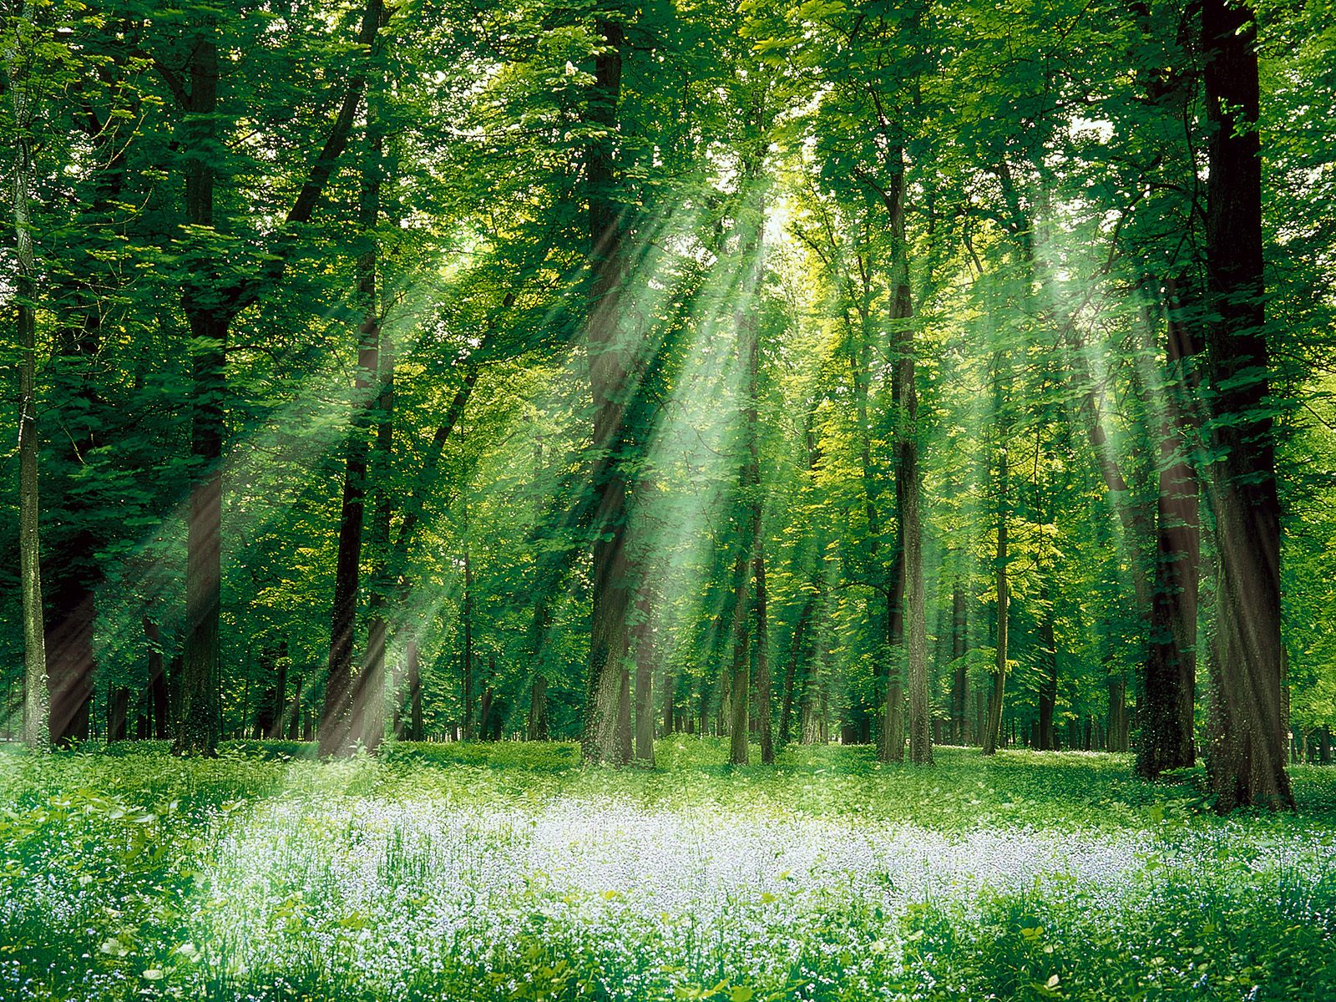

***53%*** of the homes in this neighborhood participated in the recycling program compared to ***61%*** on average in Montgomery county. Our goal is to recycle ***70%*** of our waste stream by the end of 2020.

**You can help this neighborhood move up the rank by recycling more.**